PROJECT SUMMARY
Integrated Rural Development through Kahriz Rehabilitation

I. WHAT IS KAHRIZ?
Kahriz is a traditional, sustainable water supply system that is built on topographical features (slopes) and fed through subterranean water, which does not require any fossil fuel or electricity for maintenance. Some amount of surface water and precipitation are drained through less water-resistant soil structures and gathered on more water-resistant layers. Through this cycle, it accumulates subterranean water and creates an aquifer.
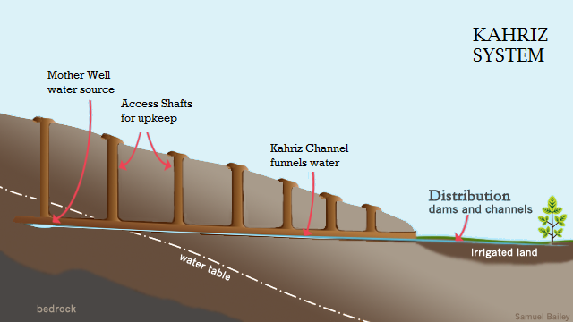
Kahriz is constructed as a gently-sloped subterranean canal by tunnelling into a cliff, scarp or base of a mountainous area, following a water-bearing formation. Unlike other man-made underground water supply and irrigation systems, kahrizes only need to tap a water-bearing zone at an elevation higher than agricultural lands. It continuously discharges the aquifer water so that users can easily adapt to the fluctuations of water level resulted from seasonal changes in climate conditions.
Kahriz has played a vital role in human life by providing underground water since ancient times across the world as similar types of water supply system have also been found in different regions, such as Iran, Turkmenistan, Eastern Turkey and Morocco. It has provided both drinking and irrigation water in many water-scarce regions, and has been proven as one of the most efficient, eco-friendly water systems since it does not require any electricity or fossil fuel for supplying water. It also contributes to preserving water aquifer and ground bed by not extracting underground water excessively.
IOM has worked on the rehabilitation of kahrizes since 20 years ago, and the efforts have been very well received globally, including by receiving the National Energy Globe Award for Sustainability: https://www.energyglobe.info/awards/details/awdid/4769/

II. PAST PROJECTS & ACHIEVEMENTS

III. CURRENT PROJECT
Since June 2018, IOM Azerbaijan has implemented the project “Integrated Rural Development for Internally Displaced Persons (IDP) Communities in Azerbaijan through Revitalization of the Kahriz Water Supply System” with financial support from the Korea International Cooperation Agency (KOICA).

The four-year project targets eight districts in Azerbaijan - namely, Aghdam, Agdjabadi, Barda, Fuzuli, Ganja, Gazakh, Goranboy and Goygol – aiming to achieve the following six main Outcomes:
- Establishment of a national master plan for kahriz revitalization
- Provision of safe and consistent water supplies for over 8,000 families across eight districts through rehabilitation of 40 kahrizes and instalment of water distribution infrastructure
- Institutionalized capacity building for kahriz engineers in collaboration with academia
- Improvement of irrigation in rural areas through instalment of water drip irrigation system and rehabilitation of irrigation ditches
- Provision of self-employment opportunities for 20 Internally Displaced Person (IDP) families through support to micro- and small-entrepreneurship set-up, including market assessments, business training and cash grants
- Community mobilization and capacity building for community-led rehabilitation and maintenance of kahrizes as well as awareness raising of the public about kahriz water supply system

IOM’s intervention strategy put women at the centre of the project’s focus as primary beneficiaries and thus managers of water supplies. This project will also contribute to Azerbaijan’s efforts to follow through on the principles of the Global Compact on Migration (GCM) and achieve the UN Sustainable Development Goals (SDGs) through:
- Provision of water for domestic and agricultural needs which has a direct impact on poverty reduction and food security – SDG 1.
- Empowering and involving women the process, increasing their role in the community leadership – SDG 5.
- Rehabilitation of eco-friendly and sustainable water supply systems, kahrizes and enhanced access to safe drinking water – SDG 6.

